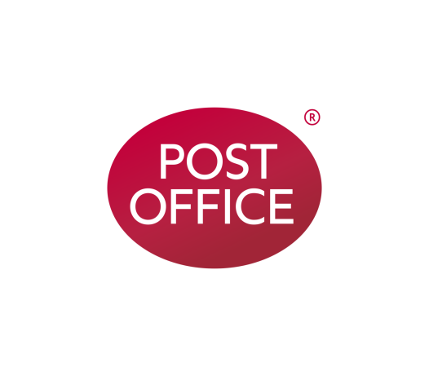

**Sutton on Sea Post Office®**

Spar, 19 High Street, Sutton on Sea,

Mablethorpe, LN12 2EY

We recently asked your views regarding access in relation to our plans to restore the Post Office service in Sutton on Sea.

We received 15 responses which welcomed the return of Post Office services to the community and we are pleased to let you know that your new branch will open here on Thursday 19 September 2019 at 13:00

.

Opening hours are:

Monday to Sunday 07:00 – 23:00

We hope that you will enjoy using the new Post Office.

|  |  |
| --- | --- |
| To view information about the branch  SCAN HERE: |  |
| **If you would like this information in Braille, large print or audio call 03452 66 01 15, Textphone 03457 22 33 55 or to see a copy of our Principles of Community Engagement about changes to the Post Office® network, visit our website postofficeviews.co.uk** | |